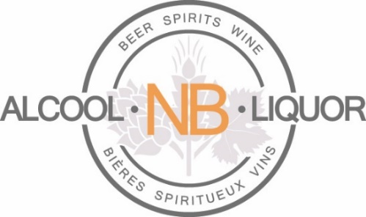

NB Liquor releases second quarter results for 2021-2022
October 27, 2021
NB Liquor released its unaudited results for the second quarter ended September 26, 2021. Total sales for the quarter (13 weeks) were $147.7 million, 3.3 per cent higher than the quarter ended on September 27, 2020 (13 weeks).

Key product sales trends for the second quarter (June 28, 2021 – September 26, 2021) compared to the second quarter last year (June 29, 2020 – September 27, 2020) were:

- wine sales increased 9.9 per cent, up $2.64 million
- spirit sales increased 4.2 per cent, up $1.23 million
- beer sales decreased 1.0 per cent, down $0.65 million and
- sales of coolers and cider increased 7.5 per cent, up $1.56 million

About ANBL

ANBL is a provincial Crown corporation responsible for the purchase, importation, distribution and retail activity for all alcoholic beverages in the province. It serves the public and licensees through 41 corporate retail outlets, 87 private agency store outlets, 87 local producer agency stores and 67 grocery stores selling wine, cider, and beer. Its product portfolio comprises more than 2,467 products, including wines, spirits, beers and other products, such as coolers and cider products, as well as locally produced alcoholic beverages.

Over the course of the last 45 years, ANBL has built a network of stores in more than 33 communities around the province and employs about 740 people.

Under an accounting convention common in the retail industry, the Corporation follows a 52-week reporting cycle, which periodically necessitates a fiscal year of 53 weeks. The Corporation’s fiscal year ends on the Sunday closest to March 31. Typically, the inclusion of an extra week occurs every fifth or sixth fiscal year due to the Corporation’s floating year-end date. The next 53-week year will occur in fiscal 2022.

Media contact: Thomas Tremblay, Communications, ANBL
506-429-2091 or media.relations@anbl.com

